- Go to AWS Console
- Search for Lambda
- Click AWS Lambda

🔹 Step 2: Click Create function
You’ll see multiple options.
✅ Choose:
Use a blueprint
👉 Click Next
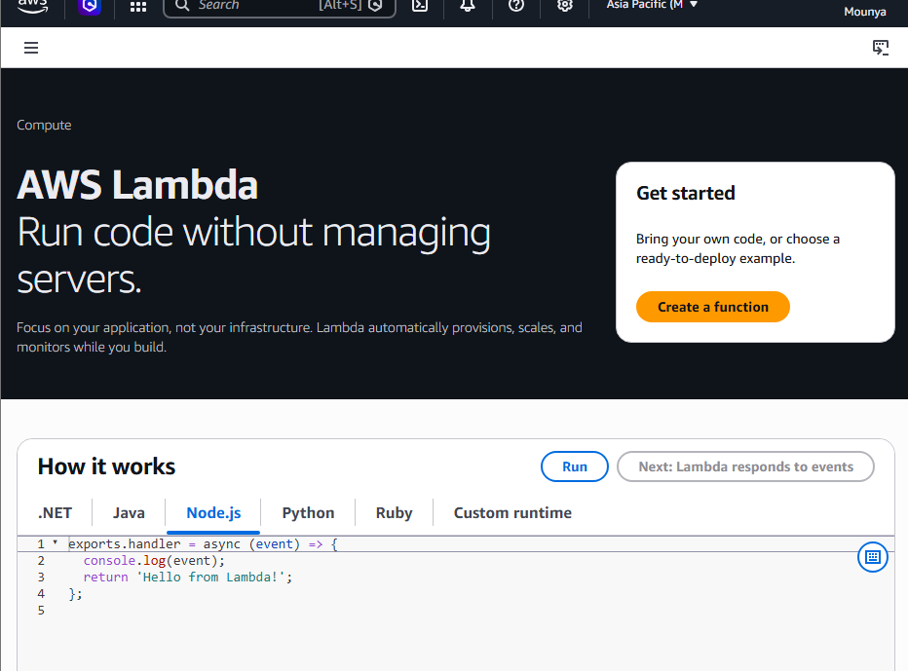

CREATE S3 BUCKET (IN PARALLEL)
🔹 Step 6: Open S3 in a new tab
- Go to S3
- Click Create bucket
- Bucket name:

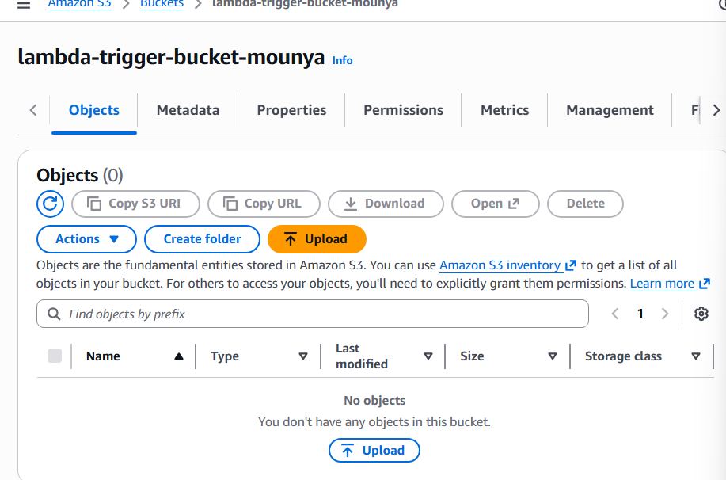

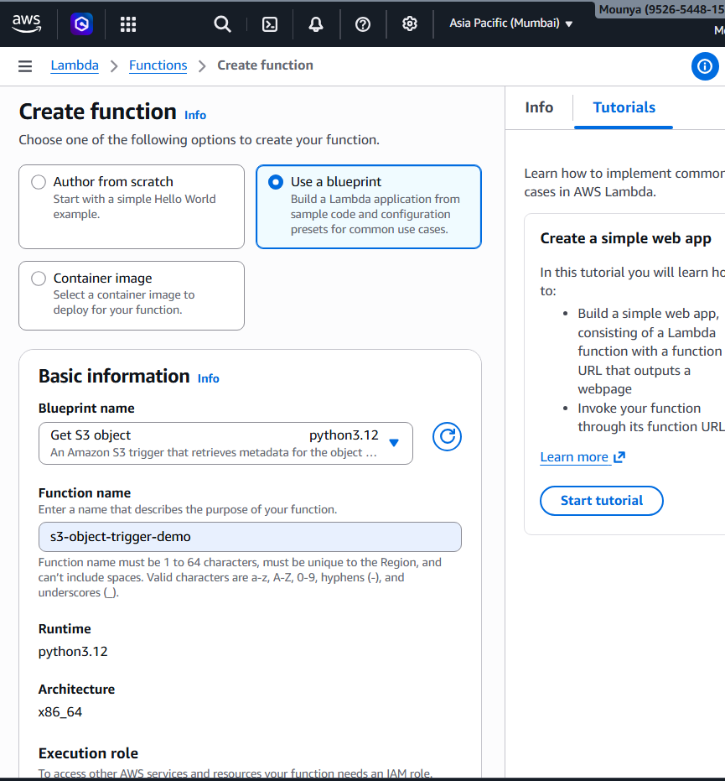

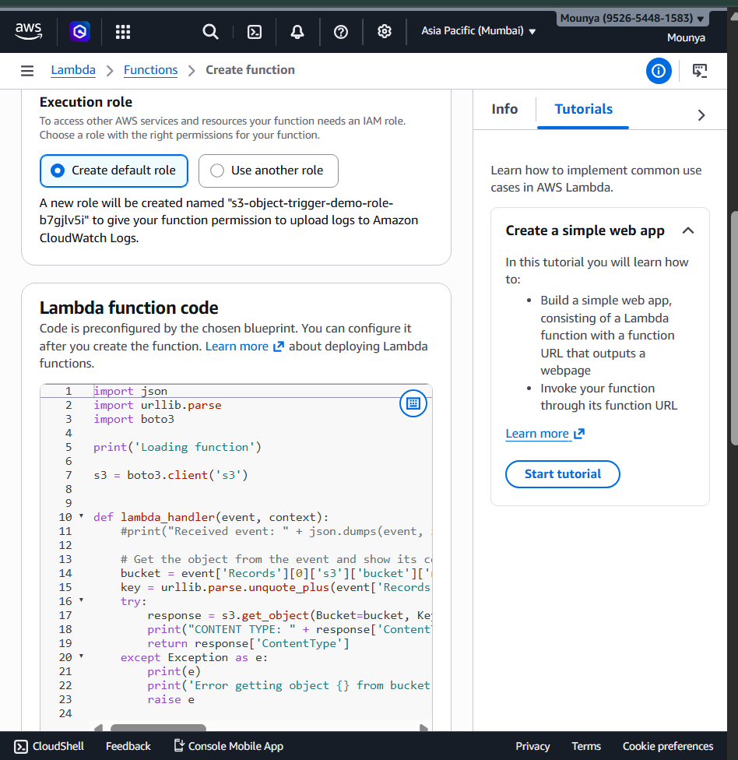

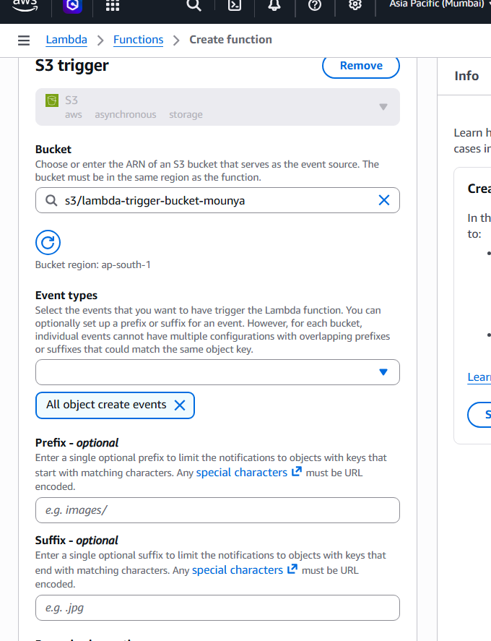

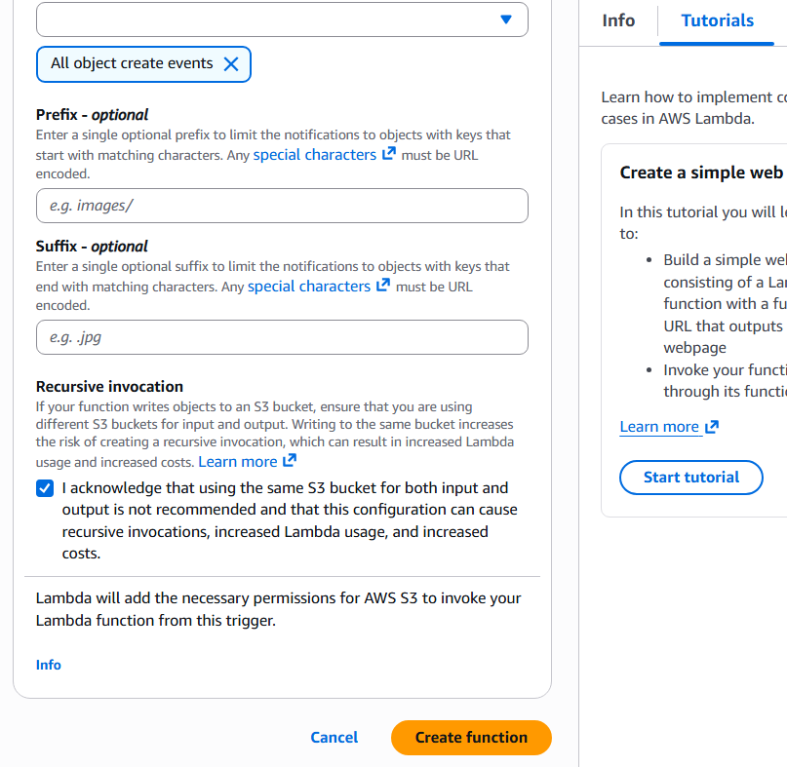

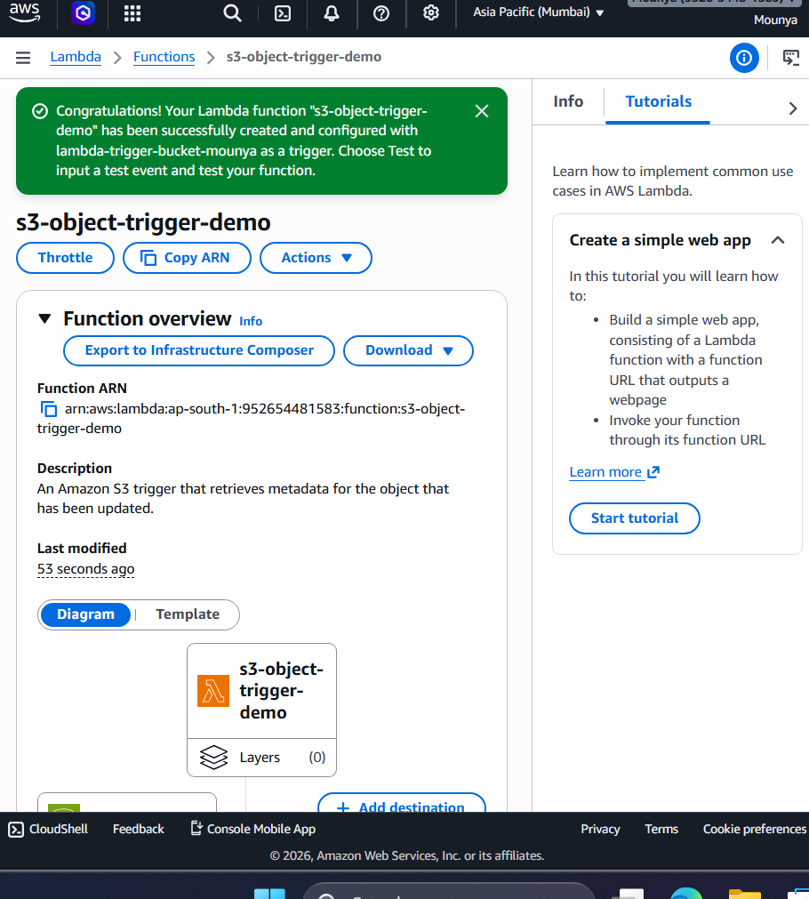
TEST THE FUNCTION
🔹 Step 8: Upload a file to S3
- Go to S3 → lambda-trigger-bucket-demo
- Click Upload
- Upload any file (text, image, etc.)

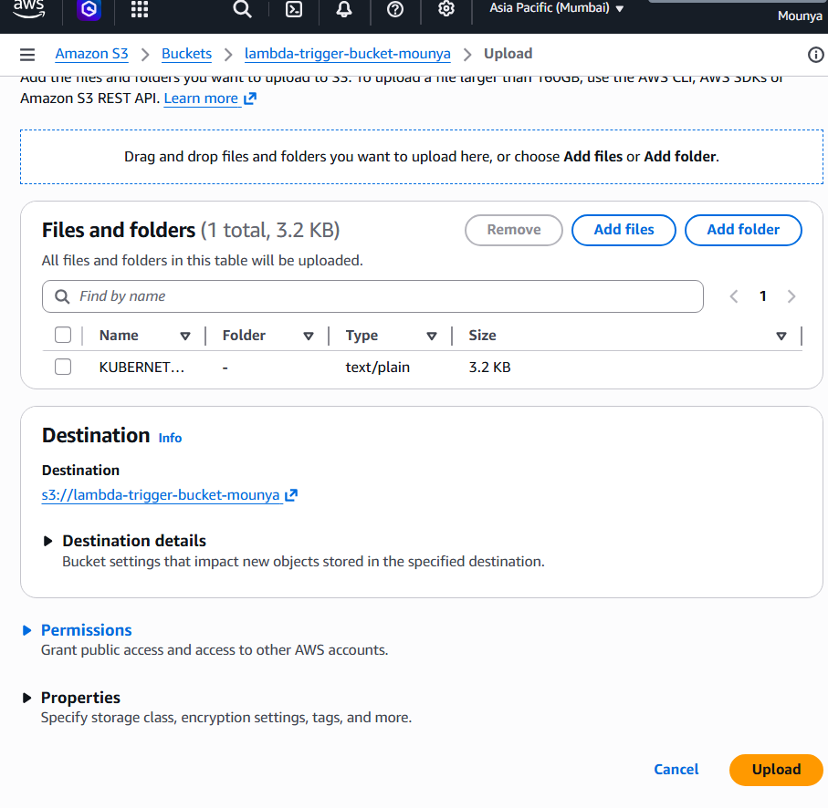

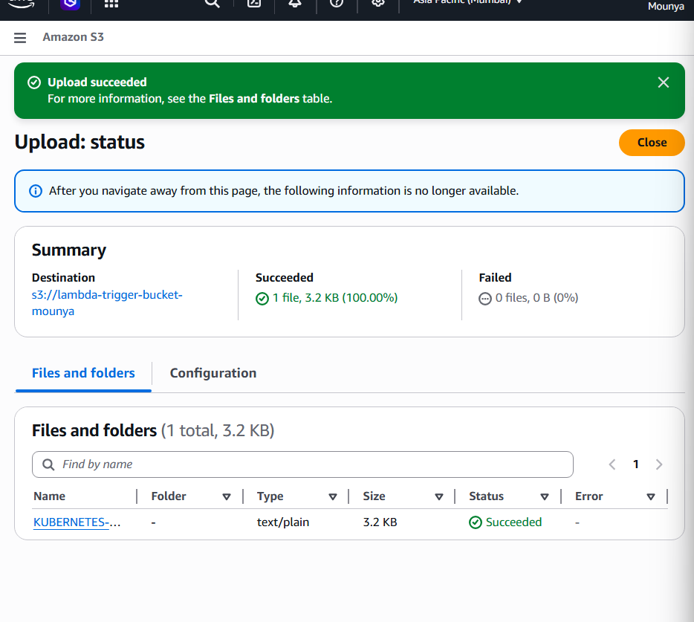

- Go to AWS Console
- Search for Lambda
- Click AWS Lambda
- You will see a list of Lambda functions
✅ From the list, click your Lambda function name
(example: s3-trigger-lambda-demo)

🔹 You are now INSIDE the Lambda function
You will see tabs like:
- Code
- Test
- Monitor
- Configuration
👉 Click the Monitor tab ✅

🔹 Open the Logs Section
Inside the Monitor tab:
- Look for a section called Logs
- You will see:
- View logs in CloudWatch
👉 Click View logs in CloudWatch ✅

🔹 You are now in CloudWatch Logs
CloudWatch will open automatically.

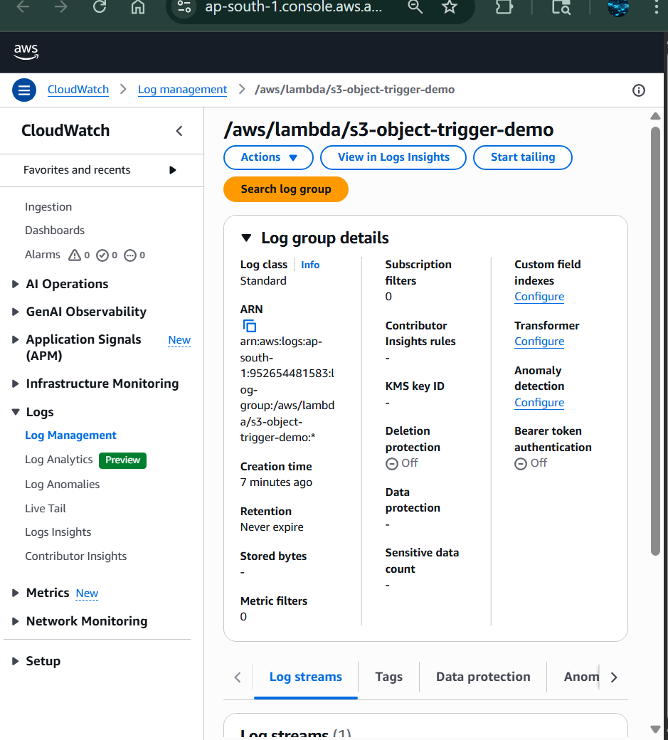
Inside the log group, you will see log streams with timestamps.
- Click the latest log stream
(the one with the most recent time)
✅ This opens the actual log messages.
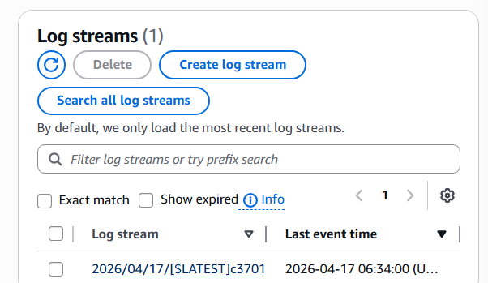

- Uploaded a file to S3
What happened internally:
- S3 detected the upload
- S3 sent an event to Lambda
- Lambda executed the blueprint code
- Lambda wrote logs to CloudWatch
- You are now reading those logs
👉 No servers, no manual run — fully automatic

